Expert Survey – School Safety Zones

Produced By
  - Krystn Orr, PhD | Physical Activity Specialist, Public Health Services, City of Hamilton
  - Callaway Johnson | Project Manager, City of Hamilton
  - Leslie Maxwell | School Travel Planning Supervisor, School Transportation Services of Waterloo Region

Date Completed
3 January 2024

Acknowledgements
We would like to thank and acknowledge the ongoing support of the School Safety Zone advisory members from across Ontario. Their support, guidance, and networking has made this project possible.
Contents
Produced By 1
Date Completed 1
Acknowledgements 1
Executive Summary 3
Overview 4
A. Current Definition of School Safety Zones 5
Methods and Methodology 5
A. Advisory Group 5
B. Survey 6
C. Recruitment 6
D. Data Analysis 6
Results 6
A. Local Context 6
B. Current Definition 6
Perceived Purpose 6
Definition Sufficiency 7
SSZ Size 7
School Entrance/Exit 7
C. Suggested Enhancements 7
Measuring the SSZ 7
Additions 8
Other Considerations 8
Tables 10

Expert Survey – School Safety Zones

Executive Summary
Purpose
The following report has three purposes.
- To explore experts’ opinions of the Highway Traffic Act’s definition and treatment of school safety zones (SSZs) in Ontario.
- To explore experts’ opinions of risks, definitions, and treatments of SSZs.
- To be the first phase in the development of recommendations for a new SSZ definition that applies to the Highway Traffic Act and for regional policies, guidelines and/or practices that impact SSZs.
Process
Under the guidance of a province-wide working group, the authors disseminated a survey from April – June 2023 (N = 73) to school board, transportation, enforcement, and public health experts across Ontario who have a professional interest in school safety zones. Divided into three categories, questions were multiple choice, ranking, and open-text questions: current SSZs, future SSZs, and the local context. The authors analyzed the data using Microsoft© Excel® and summarized for discussion with the working group.
Outcomes
The experts provided feedback that strongly indicates a need to:
- Explore new definitions of SSZs within the Highway Traffic Act and associated regional policies and/or guidelines.
- Establish best practices for application of the current definition to effectively support active school travel and the safety of children near schools.
- Engage with the community on next steps of policy development and implementation (Phase 2 of the working group’s process).

Overview
In early 2023, 13 experts from the public health, transportation, and education sectors with an interest in and professional knowledge of school safety zones (SSZs) came together to explore whether the Ontario Highway Traffic Act’s (HTA) definition and use of School Safety Zones developed in 1995 serves today’s needs. This small group was responding to regular reports from families and school staff who often consider SSZs the most dangerous area for students on the way to school. Supporting the experiences of families and school staff, observational studies of SSZs have identified dangerous driving behaviours occurring daily at 88% of observed schools.
The HTA first defined SSZs in 1995 when neighbourhoods and transportation demands were different than they are in 2023. In 1995, fewer families drove students in single-family vehicles and more students used active modes of travel. Hence, the HTA focused on speed reduction. However, in the almost 30 years of defined SSZs, the number of students driven to school has grown, increasing the number of single-family vehicles travelling in and around school zones and intensifying risks to children due to congestion and unsafe maneuvers by drivers.
The additional vehicular traffic by families and community members poses significant safety concerns (e.g., sight line issues and challenging crossings for pedestrians), environmental risks (e.g., increased air pollution in a concentrated area), and decreased overall health and wellbeing (e.g., less physical activity is related to poor mental and physical health as well as academic performance). These congested areas relate to poor decision-making by drivers, and pinch points for vehicles and vulnerable road users.
Families dropping off and picking up students at schools contribute to increased safety concerns within SSZs. With more drop offs and pick ups occurring on roads adjacent to schools, there are more children crossing roadways and parking areas at official/unofficial crossings. A greater volume of vehicles contributes to poor sight lines, congestion, and poor air quality that puts students at risk for vehicle-pedestrian collisions, and poorer health and wellbeing. In addition, families who witness this congestion suffer increased fear of the roads and are less likely to allow their children to use active school travel.
In recent years, focus has been on evidence-informed solutions to address challenges of SSZs that are unaddressed by the current definition and treatments afforded in the HTA. The founding principle is that vulnerable road users such as children “be separated in time and space from motor vehicles, and where this is not possible, traffic speeds should be capped at 30 km/hr reflecting crash survivability.” This survey and report explores experts’ perspectives on the purpose of SSZs and the changes they recommend for Ontario guidelines and policies to produce greater safety in school zones.

Current Definition of School Safety Zones
Highway Traffic Act Item 128 (5)
The council of a municipality may by by-law,
(a) designate a portion of a highway under its jurisdiction that adjoins the entrance to or exit from a school and that is within 150 metres along the highway in either direction beyond the limits of the land used for the purposes of the school: and,
(b) for motor vehicles driven, on days on which school is regularly held, on the portion of a highway so designated, prescribe a rate of speed that is lower than the rate of speed otherwise prescribed under subsection (1) or (2) for that portion of highway, and prescribe the time or times at which the speed limit is effective.
R.S.O. 1990, c. H.8, s. 128 (5); 2002, c. 17, Sched. F, Table; 2002, c. 18, Sched. P, s. 29 (2); 2006, c. 32, Sched. D, s. 4 (6).

Methods and Methodology

Advisory Group
In November 2022, the authors invited experts working with SSZs from across Ontario to a meeting to discuss the project (hereon, advisors). The authors selected advisors based on prior partnerships and ongoing professional interest in SSZs. In total, ten advisors and three authors supported the development of this SSZ project. Since November 2022, the advisory group has met three times to provide feedback and discuss the project’s goals and processes with the opportunity to provide further feedback via email.

Survey
The three authors, with feedback from the advisors, designed the survey. The survey aims to (1) understand the local SSZ context, (2) explore perceptions of the current SSZ definition within the HTA, and (3) explore options for enhancing SSZs. The survey questions can be accessed here. The authors created and circulated the survey using Microsoft© Forms®.

Recruitment
Using purposeful and snowball sampling between 4 April 2023 and 30 June 2023, the survey link circulated across Ontario. The intended respondents were individuals working with SSZs in a professional capacity (hereon, experts). Using existing communication channels, the authors and advisors emailed the link with a call for the individual receiving the email to complete the survey and/or to pass it along to a more appropriate respondent. Three reminder emails went out through the communication channels to encourage further responses.

Data Analysis
The first author exported the data into Microsoft© Excel® for analysis. Quantitative data underwent descriptive and correlational statistical analysis, while qualitative data underwent general qualitative analysis. Together the qualitative and quantitative data provides an integrated and fulsome depiction of the local, current, and potential future of SSZs.

Results

Local Context
There were seventy-three experts from across Ontario who participated in this survey (Figure 1). To protect respondent anonymity, the survey did not include location or other identifying information. Experts came from municipal government (n = 46), education (n = 15), non-government organizations (n = 3), and four (n = 4) preferred not to answer. Table 1 provides a breakdown of their roles.

Current Definition

Perceived Purpose
When asked what the current definition indicates is the SSZ’s purpose, they primarily answered “to manage traffic speed” (n = 51) and “to indicate that a school is nearby” (n = 37). Comparatively, when asked what purpose the SSZ should serve, the experts answered in open text that protection of vulnerable road users such as children, pedestrians, and cyclists, and drivers’ awareness that there is a high likelihood of encountering children.

Safety Concerns in SSZs
Respondents ranked nine potential safety concerns in SSZs. Children’s safety crossing streets (62.5%), children using active transportation (43.1%), and children accessing school buses (50.0%) were the top three concerns, respectively. Contrastingly, community members (38.9%) and vehicular traffic efficiency (62.5%) were the least important (Table 2).

Definition Sufficiency
Given the current HTA definition of SSZs, experts rated the definition as insufficient (53.4%) or partially sufficient (28.8%). Experts who reported the definition was sufficient were more likely to consider the definition’s purpose to address vehicular movements (r (71) = .01, p = .05) and speed management (r (71) = .003, p = .05). Figure 1 provides a further breakdown of the definition’s sufficiency by purpose.

SSZ Size
The HTA definition provides a minimum SSZ size of 150 metres. Experts reported using minimum SSZs across districts. Additionally, experts reported school active travel areas (i.e., areas close enough to the school that students are ineligible for a school bus) were on average 1 571 metres. Thus, there is a perceived 1 471-metre discrepancy between how far students must travel for school and the SSZ (Figure 2).

School Entrance/Exit
The HTA does not explicitly define the entrance/exit of a school. Thus, the experts perceived the entrance/exit to be for drivers only (38.9%), active travel users only (8.3%), and both (43.1%). Seven experts (9.7%) selected “other” and expanded by sharing their confusion over the ambiguity of the definition. Figure 3 graphically depicts the perceived intended users of school entrances/exits.

Suggested Enhancements

Measuring the SSZ
Table 3 defines five options for measuring a SSZ based on current practices and peer-reviewed literature that aims to improve safety in SSZs. Experts significantly preferred to treat SSZs similarly to community safety zones where local authorities can determine length and position of the safety zone (n = 23, 31.5%) or to include all portions of highway surrounding the school (n = 21, 28.8%).
Additionally, most experts (n = 55, 75.3%) reported that the 150-metre maximum SSZ are too small.

Additions
In addition to expanded SSZ sizes and the current speed rate management, experts reported a desire for additional regulations to control dangerous driving behaviours and increase vulnerable road user safety (Figure 4). Experts selected elements that should be in a new policy addressing SSZs and had the opportunity to expand on their responses in a subsequent open text question. Additions included:
- Implementing pedestrian-first crossings (i.e., crossing treatments that give pedestrians the right of way) (81.9%).
- Parking restrictions on the school (80.6%) and opposite sides of the highway (61.1%).
- Restricting U-turns (75.0%).
- Increased fines for distracted driving (73.6%); and
- Increased fines for all existing road laws (70.8%).
Further comments around additional measures to increase vulnerable road user safety in SSZs noted a need for using multiple measures rather than speed management only.

Other Considerations
When implementing any changes to the HTA’s SSZs, experts offered additional comments through open text questions indicating a need for additional human and financial resources (Figure 6) to implement any associated changes. Experts were also concerned about the communication and education strategies needed to bring awareness to the risks of SSZs and the regulatory changes that may occur. Moreover, with the suggested increased safety regulations noted above, experts conveyed their apprehension over the resources needed to adequately enforce the SSZs. Thus, next steps must incorporate community engagement and multi-sector partnerships to ensure there is alignment and support from all end-users.
Contrastingly, experts highlighted built environment and program changes that could occur to enhance SSZ efficiency. Of note were the use of complete street designs that place vulnerable road users at the centre of neighbourhood design. Additionally, school streets were encouraged for increasing student safety and overall wellbeing. Therefore, more research is needed to explore the feasibility, implementation, community engagement, and financial supports necessary for addressing these potential built environment and program changes.

Tables
Table 1. Expert respondents by their sector and roles.
Sector | N (%) | Roles | n (%)
Municipal Government | 46 (63.0%) | Transportation Parking and Planning  Transportation Engineering  Law Enforcement  Public Health  Crossing Guard Programs | 14 (30.4%)  13 (28.3%)  2 (4.3%)  8 (17.4%)  9 (19.6%)
Education | 15 (20.5%) | Educator  School Administrator  School Board Facilities  School Board Planning | 1 (6.7%)  10 (66.7%)  1 (6.7%)  3 (20.0%)
Non-Government | 8 (10.9%) | Researcher  Non-Profit/Charity  Other | 1 (12.5%)  5 (62.5%)  2 (25.0%)
Prefer Not to Answer | 4 (5.5%)

Table 2. Ranking of safety concerns in SSZs.

Table 3. Proposed alternative methods to measuring a SSZ (χ²(4, N=73) = 14.05, p = .007).
Proposed Zone Measurement | n
Portion of highway at the school frontage (current definition) | 5
Portions of highway on all sides of school block | 21
Designated similarly to a Community Safety Zone | 23
Concentric circle from school site | 13
Other | 11

*
*
Figure 1. Sufficiency of current SSZ definition by perceived purpose. *Significant correlation, p < .05.

Figure 2. Student active travel distances compared to school safety zone sizes as reported by expert sector.

Figure 3. Does “entrance/exit to the school” as defined by the HTA refer to where drivers enter the school or where pedestrians/cyclists enter the school? This question indicates whether the definition clearly defines the focal point for the SSZ or not. (χ2(3, N=72) = 29.67, p = .00001)

Figure 4. Expert choices of elements that should in consideration in new policy addressing SSZs.

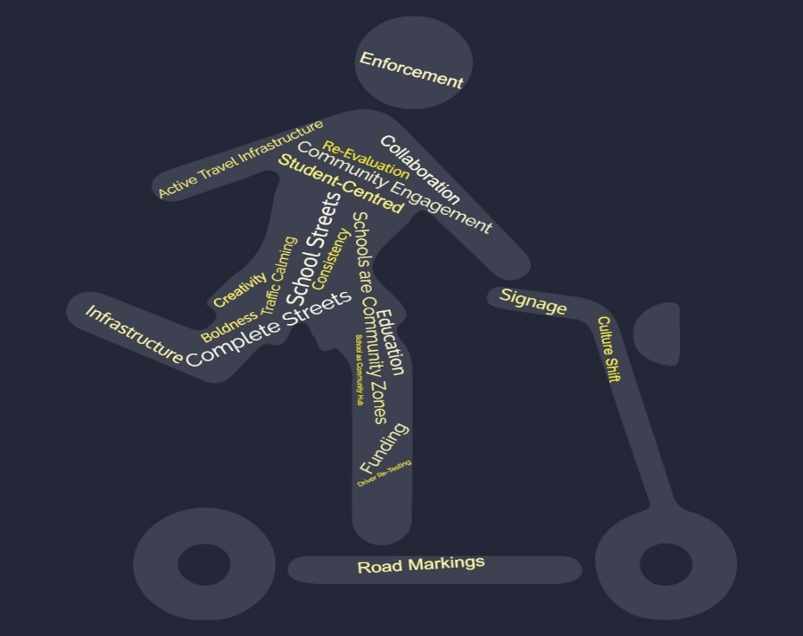
Figure 5. Methods and considerations for effecting change to SSZs contributed to open-ended question.

Ontario Active School Travel. (2020). An urgent problem. Ontario Active School Travel. https://ontarioactiveschooltravel.ca/an-urgent-problem/
Rothman L, Howard A, Buliung R, Macarthur C, Macpherson A. Dangerous student car drop-off behaviors and child pedestrian-motor vehicle collisions: An observational study. Traffic Inj Prev. 2016 Jul 3;17(5):454-9. doi: 10.1080/15389588.2015.1116041. Epub 2016 Jan 13.
Ontario Active School Travel. Benefits of active school travel. 2020. https://ontarioactiveschooltravel.ca/benefits-of-active-school-travel/
Unhaggle. The dangerous effects of commuting on your brain. October 22, 2013. https://blog.unhaggle.com/commuting-dangers/
Cloutier M-S, Beaulieu E, Fridman L, et al. State-of-the-art review: Preventing child and youth motor vehicle collisions: Critical issues and future directions. Inj Prev 2020 27(1): 77-84. doi:10.1136/injuryprev-2020-043829. (P. 82)
Highway Traffic Act, Pub. L. No. R.S.O. 1990, c. H.8, King’s Printer for Ontario (2023). https://www.ontario.ca/laws/statute/90h08#BK0
Maisel, J. L., Baek, S.-R., & Choi, J. (2021). Evaluating users’ perceptions of a Main Street corridor: Before and after a Complete Street project. Journal of Transport & Health, 23, 101276. https://doi.org/10.1016/j.jth.2021.101276
McAndrews, C., Schneider, R. J., Yang, Y., Kohn, G., Schmitz, A., Elliott, F., Pittner, J., & Purisch, H. (2022). Toward a gender-inclusive complete streets movement. Journal of Planning Literature, 088541222210874. https://doi.org/10.1177/08854122221087472
City of Hamilton. (2023). Complete Streets Design Manual. City of Hamilton. https://www.hamilton.ca/build-invest-grow/planning-development/planning-policies-guidelines/complete-streets-design-manual
8 80 Cities. (2023). School streets. 8 80 Cities. https://www.880cities.org/portfolio_page/school-streets/

